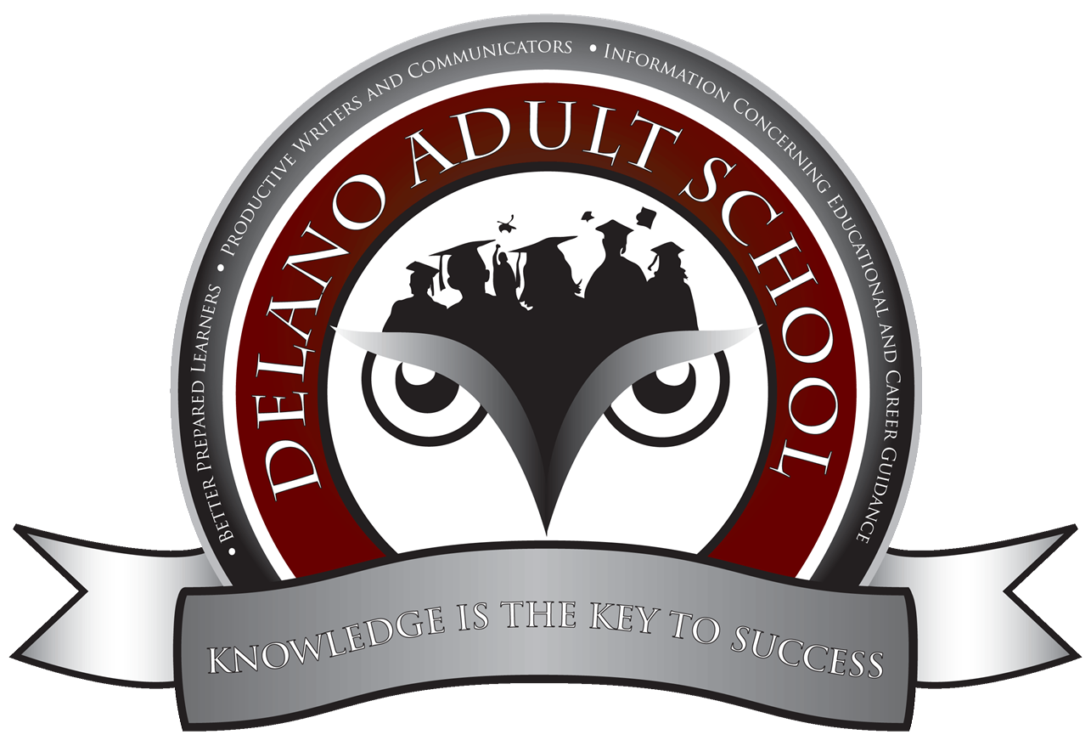
2023 – 2024: Instructor: Mr. Coronado and Aide: Ms. Lorena Room 1

Course Description:

This course is for students who intend to improve their English to a conversational level and writing in paragraphs. This course also prepares students for ESL 4-5, where instruction is in English whereas in this class instruction will be in both English and Spanish.

Placement of Students in the Academic Transitions Course

- ESL (English as a Second Language): Students who qualify for Levels 2-3 in the DAS based on CASAS scores and instructor discretion.

Student Learning Outcomes:

1. Communicate effectively and Think Critically.
2. Collaborate collectively as productive Members of the Community.
3. Contribute responsibly to the diversity of a global economy and society by means of
foundational skills and technology.
4. Complete a successful transition into the Work Force and/or a higher level learning for the
purposes of obtaining a career.

Student Learning Objectives*:

*Based on College and Career Readiness Standards for Adult Education Susan Pimentel 2013 and English Language Proficiency Standards for Adult Education October 2016

- CASAS Test Scoring: Students in ESL 2-3 are from the CASAS ESL Scoring Range of 205 to 219 (Teacher discretion also as to speaking, listening, and writing levels since the CASAS test is a Reading Test). The Objective is for students to achieve an improvement of a minimum of 1-5 points per quarter. The ultimate goal is to reach the CASAS Scoring Range of 220 and above and to advance to ESL 4-5.
- Writing: Students in ESL 2-3 typically are able to write simple complete sentences with some assistance. The Objective is for students within one semester to achieve the ability to write a basic coherent paragraph of 3-5 sentences composed of corresponding level vocabulary that includes the components of Topic Sentence, Supporting Evidence, and Personal Commentary (interpretation and analysis) with a Concluding thought.
  - English Language Proficiency Standards for Adult Education With Correspondences to the College and Career Readiness Standards for English Language Arts.
    - Example Page 33 CCR Anchor 1: Demonstrate command of the conventions of standard English grammar and usage when writing or speaking.
      - C Level Demonstrate command of the conventions of standard English grammar and usage when writing or speaking. a. Explain the function of conjunctions, prepositions, and interjections in general and their function in particular sentences. b. Use relative pronouns (who, whose, whom, which, that) and relative adverbs (where, when, why). c. Form and use the progressive (e.g., I was walking; I am walking; I will be walking) verb tenses.
    - Example Page 51 CCR Writing Anchor 6: Use technology, including the Internet, to produce and publish writing and to interact and collaborate with others. CCR Writing 6 Level E • Use technology, including the Internet, to produce, publish, and update individual or shared writing products, taking advantage of technology’s capacity to link to other information and to display information flexibly and dynamically. (W.9-10.6)
      - By the end of English language proficiency level 3, an ELL can… • participate in conversations, discussions, and written exchanges about familiar topics, texts, and issues • build on the ideas of others • express his or her own ideas • ask and answer relevant questions • add relevant information and evidence • restate some of the key ideas expressed • follow rules for discussion • ask questions to gain information or clarify understanding.
- Reading: Students in ESL 2-3 typically are able to read books from the Burlington English program labeled Beginner or Intermediate. The Objective is for students within one semester to achieve the ability to read a basic paragraph composed of corresponding level vocabulary.
- English Language Proficiency Standards for Adult Education With Correspondences to the College and Career Readiness Standards for English Language Arts.
  - Example Page 35 CCR Reading Anchor 1: Read closely to determine what the text says explicitly and to make logical inferences from it; cite specific textual evidence when writing or speaking to support conclusions drawn from the text.
    - By the end of English language proficiency level 3, an ELL can… use a developing set of strategies to: • determine a central idea or theme in oral presentations and spoken and written texts • retell key details • answer questions about key details • explain how the theme is developed by specific details in texts • summarize part of a text.
- Speaking and Listening: Students in ESL 2-3 typically are able to speak and listen to simple sentences (a simple sentence defined grammatically as one independent clause i.e. one subject and one predicate) composed of corresponding level vocabulary.
  - English Language Proficiency Standards for Adult Education With Correspondences to the College and Career Readiness Standards for English Language Arts.
    - Example Page 55: CCR Speaking and Listening 1 Level E • Initiate and participate effectively in a range of collaborative discussions (one-on-one, in groups, and teacher-led) with diverse partners, building on others’ ideas and expressing their own clearly and persuasively.
      - By the end of English language proficiency level 3, an ELL can… • participate in conversations, discussions, and written exchanges about familiar topics, texts, and issues • build on the ideas of others • express his or her own ideas • ask and answer relevant questions • add relevant information and evidence • restate some of the key ideas expressed • follow rules for discussion • ask questions to gain information or clarify understanding.

Scope and Sequence

This is based on the five EL Objectives provided for each academic school year. Typical modules include the following:

- #13 Education
- #19 Immigrant Resources
- #52 Work Place Readiness
- #12 Community Resources DMV
- #40 Citizenship
- #46 Nutrition

Attendance Policy

- Each student is allowed 5 unexcused absences within each quarter. After 5 unexcused absences, the student will be contacted and may be dropped from the course for the rest of the quarter.
- An excused absence must be communicated and is defined by a true emergency (sickness or personal tragedy) and not inconvenience (lack of transportation, babysitting, etc.). Please communicate with your teacher as the staff at DAS always tries their best to assist students. Having said this, we also do ask that students understand it is disruptive to the class if they arrive late or leave early.
- Students should arrive within 15 minutes of the beginning of class. After 15 minutes, a tardy will be assigned (three tardies is equivalent to an absence). After 30 minutes, the student will receive an absence. This same policy applies to students who leave the class early.
- Students may communicate with Mr. James and Ms. Lorena via our ESL 2-3 Whatsapp Group or Schoology (students may call the office, but direct communication with the teacher and/or teacher aide is preferable).

Texts

- Stand Out Levels 2 and 3
- Voices of Freedom
- Citizenship
- Grammar in Context
- Supplementary materials (teacher designed)

Computer Programs

- Schoology
- Burlington English
  - Range: Low Beginners to High Beginners to Low Intermediate
  - EL Civics: English in America Intermediate
  - Career Exploration and Soft Skills Intermediate
  - Grammar: Beginners to Intermediate
  - Readers: Beginners to Advanced

Supplies

- Notebook and Paper
- Pencils and Pens

Classroom Expectations

- Please be respectful to your teacher and your classmates
- No food is allowed in classroom according to DAS policy. Drinks must have a sealable lid (no straws).
- Please arrive to class on time and please do not leave until the class is dismissed.

Benchmarks

- EL Civics Assessments (5 units usually consisting of 3 tests regarding listening/speaking, reading and writing skills)
- CASAS Scores
- Government and History Test
- Citizenship Test
- Academic paragraph writing (4-6 sentences with basic sentence structure and basic vocabulary to form different and specific task oriented sentences)
- Reading analysis of informational text and literature (including songs and poems)
- Video analysis (listening comprehension to understand spoken English in short videos)
- Speaking in dialogue (intermediate comprehension and fluency)

